  

SHIELDING SYSTEM FOR OFFSCUM LABOURS USING IOT WITH SENSORS

## A MINOR PROJECT - III REPORT

***Submitted by***

|  |  |
| --- | --- |
| **S.SHALINI** | **927621BEC194** |
| **R.SNEHA** | **927621BEC203** |
| **R.SNEHA** | **927621BEC204** |
| **P.VASUNTHRA** | **927621BEC237** |

# BACHELOR OF ENGINEERING

in

# DEPARTMENT OF ELECTRONICS AND COMMUNICATION ENGINEERING

**M.KUMARASAMY COLLEGE OF ENGINEERING**

(Autonomous)

# KARUR – 639 113

**OCTOBER 2023**

M.KUMARASAMY COLLEGE OF ENGINEERING, KARUR

# BONAFIDE CERTIFICATE

Certified that this **18ECP105L - Minor Project III** report “**SHIELDING SYSTEM FOR OFFSCUM LABOURS USING IOT WITH SENSORS ”**is the bonafide work of **“R.SNEHA (927621BEC204), S.SHALINI (927621BEC194), R.SNEHA (927621BEC203),P.VASUNTHRA (927621BEC237) ”** who carried

out the project work under my supervision in the academic year 2023-2024-ODD SEMESTER.

**SIGNATURE SIGNATURE**

**Dr.A.KAVITHA B.E., M.E., Ph.D., Dr.A.SRIDEVI**,

**HEAD OF THE DEPARTMENT, SUPERVISOR,**

Professor, **Job Title – AP/ASP/Prof**>>,

Department of Electronics and Department of Electronics and

Communication Engineering, Communication Engineering, M.Kumarasamy College of Engineering, M.Kumarasamy College of Engineering, Thalavapalayam, Thalavapalayam,

Karur-639113. Karur-639113.

This report has been submitted for the **18ECP105 – Minor Project-III** final review held at M. Kumarasamy College of Engineering, Karur on **<<Final Review Date (DD-MM-**

**YYYY) >>.**

**PROJECT COORDINATOR**

# INSTITUTION VISION AND MISSION

**Vision**

To emerge as a leader among the top institutions in the field of technical education.

**Mission**

**M1:** Produce smart technocrats with empirical knowledge who can surmount the global challenges.

**M2:** Create a diverse, fully -engaged, learner -centric campus environment to provide quality education to the students.

**M3:** Maintain mutually beneficial partnerships with our alumni, industry and professional associations

# DEPARTMENT VISION, MISSION, PEO, PO AND PSO

**Vision**

To empower the Electronics and Communication Engineering students with emerging technologies, professionalism, innovative research and social responsibility.

**Mission**

**M1:** Attain the academic excellence through innovative teaching learning process, research areas & laboratories and Consultancy projects.

**M2:** Inculcate the students in problem solving and lifelong learning ability.

**M3:** Provide entrepreneurial skills and leadership qualities.

**M4:** Render the technical knowledge and skills of faculty members.

**Program Educational Objectives**

**PEO1: Core Competence:** Graduates will have a successful career in academia or industry associated with Electronics and Communication Engineering **PEO2: Professionalism:** Graduates will provide feasible solutions for the challenging problems through comprehensive research and innovation in the allied areas of Electronics and Communication Engineering.

**PEO3: Lifelong Learning:** Graduates will contribute to the social needs through lifelong learning, practicing professional ethics and leadership quality **Program Outcomes**

**PO 1: Engineering knowledge:** Apply the knowledge of mathematics, science, engineering fundamentals, and an engineering specialization to the solution of complex engineering problems.

**PO 2: Problem analysis:** Identify, formulate, review research literature, and analyze complex engineering problems reaching substantiated conclusions using first principles of mathematics, natural sciences, and engineering sciences.

**PO 3: Design/development of solutions:** Design solutions for complex engineering problems and design system components or processes that meet the specified needs with appropriate consideration for the public health and safety, and the cultural, societal, and environmental considerations.

**PO 4: Conduct investigations of complex problems:** Use research-based knowledge and research methods including design of experiments, analysis and interpretation of data, and synthesis of the information to provide valid conclusions.

**PO 5: Modern tool usage:** Create, select, and apply appropriate techniques, resources, and modern engineering and IT tools including prediction and modeling to complex engineering activities with an understanding of the limitations.

**PO 6: The engineer and society:** Apply reasoning informed by the contextual knowledge to assess societal, health, safety, legal and cultural issues and the consequent responsibilities relevant to the professional engineering practice.

**PO 7: Environment and sustainability:** Understand the impact of the professional engineering solutions in societal and environmental contexts, and demonstrate the knowledge of, and need for sustainable development.

**PO 8: Ethics:** Apply ethical principles and commit to professional ethics and responsibilities and norms of the engineering practice.

**PO 9: Individual and team work:** Function effectively as an individual, and as a member or leader in diverse teams, and in multidisciplinary settings.

**PO 10: Communication:** Communicate effectively on complex engineering activities with the engineering community and with society at large, such as, being able to comprehend and write effective reports and design documentation, make effective presentations, and give and receive clear instructions.

**PO 11: Project management and finance:** Demonstrate knowledge and understanding of the engineering and management principles and apply these to one’s own work, as a member and leader in a team, to manage projects and in multidisciplinary environments.

**PO 12: Life-long learning:** Recognize the need for, and have the preparation and ability to engage in independent and life-long learning in the broadest context of technological change.

**Program Specific Outcomes**

**PSO1:** Applying knowledge in various areas, like Electronics, Communications, Signal processing, VLSI, Embedded systems etc., in the design and implementation of Engineering application.

**PSO2:** Able to solve complex problems in Electronics and Communication Engineering with analytical and managerial skills either independently or in team using latest hardware and software tools to fulfil the industrial expectations.

|  |  |
| --- | --- |
| **Abstract** | **Matching with POs, PSOs** |
| Panic Button Ultrasonic Sensor Temperature Sensor Toxic Gas Sensor  Arduino Atmega 328P | PO1,PO2,PO3,PO4,PO5,PO6,PO7,PO8,PO9,PO10, PO11, PO12, PSO1, PSO2 |

# ACKNOWLEDGEMENT

Our sincere thanks to **Thiru.M.Kumarasamy, Chairman** and **Dr.K.Ramakrishnan, Secretary** of **M.Kumarasamy College of Engineering** for providing extraordinary infrastructure, which helped us to complete this project in time.

It is a great privilege for us to express our gratitude to **Dr.B.S.Murugan., B.Tech., M.Tech., Ph.D., Principal** for providing us right ambiance to carry out this project work.

We would like to thank **Dr.A.Kavitha, Professor and Head**, **Department of Electronics and Communication Engineering** for his unwavering moral support and constant encouragement towards the completion of this project work.

We offer our wholehearted thanks to our **Project Supervisor, <<Guide Name, Degree, Job Title>>**, Department of Electronics and Communication Engineering for his precious guidance, tremendous supervision, kind cooperation, valuable suggestions, and support rendered in making our project successful.

We would like to thank our **Minor Project Co-ordinator**, **Dr.K.Karthikeyan, B.E., M.Tech., Ph.D., Associate Professor**, Department of Electronics and Communication Engineering for his kind cooperation and culminating in the successful completion of this project work. We are glad to thank all the Faculty Members of the Department of Electronics and Communication Engineering for extending a warm helping hand and valuable suggestions throughout the project. Words are boundless to thank our Parents and Friends for their motivation to complete this project successfully.

# ABSTRACT

Many sanitary labors die each year due to irregularities, unavailability of equipment, and harmful toxic gases released during sewage treatment. Actual well-being health observing system for such labors would be useful. This real-time health monitor acts as a safety device in the sewage. In this post, the featured device is intended to use temperature sensors and toxic gas sensor to alert workers and field services. If the parameter is out of the safe area. These real-time parameters ensure safety before harming workers and immediately warn them to detect toxic gases. The main component of this system is Arduino controller. Various sensors are used for the proposed system. (Toxic Gas Sensor, Temperature Sensor, Ultrasonic Sensor and Panic Button). If sensor level exceeds the limit, Vibrator will be ON. The readings of the sensor will be displayed on LCD at receiver with help of IOT.

## TABLE OF CONTENTS

|  |  |  |  |  |  |
| --- | --- | --- | --- | --- | --- |
| **CHAPTER No** | | **CONTENTS** | | | **PAGE No.** |
|  | **Institution Vision and Mission** | | | | iii |
|  | **Department Vision and Mission** | | | | iii |
|  | **Department PEOs, POs and PSOs** | | | | iv |
|  | **Abstract** | | | | viii |
|  | **List of Figures** | | | |  |
|  | **List of Abbreviations** | | | |  |
| 1 | **INTRODUCTION** | | | | 1 |
|  | 1.1 EMBEDDED SYSTEM | | | | **2** |
|  | 1.2 | | INTERNET OF THINGS | | 4 |
|  |  | | 1.2.1.Benefits of IoT | | 4 |
|  |  | | 1.2.2 | IoT Application Areas | 4 |
|  |  | |  |  |  |
| **2** | **LITERATURE SURVEY** | | | | **5** |
|  | 2.1 | | Photoplethysmograghy based heartrate  monitoring | | 6 |
|  | 2.2 | | A low power miniaturized monitoring  system | | 6 |
| **3** | **EXISTING SYSTEM`** | | | | **7** |
| **4** | **PROPOSED SYSTEM** | | | | 8 |
| **5** | **HARDWARE REQUIREMENTS** | | | | 10 |
| **6** | **HEALTH IOT PLATFORM BASED** | | | | 17 |
| **7** | **RESULT AND DISCUSSION** | | | | 18 |
| **8** | **CONCLUSION AND FUTUTE WORK** | | | | 19 |
|  | **REFERENCES** | | | | 20 |
|  |  | | | |  |

## LIST OF FIGURES

|  |  |  |
| --- | --- | --- |
| **FIGURE No.** | **TITLE** | **PAGE No.** |
| 4.1 | Monitoring system for sewages workers | 8 |

* 1. Workflow of the monitoring system 9
  2. IoT Setup 19

## LIST OF ABBREVIATIONS

|  |  |
| --- | --- |
| **ACRONYM** | **ABBREVIATION** |

HRM - Heart Rate Measuring Device

IOT - Internet Of Things

LCD - Liquid Crystal Display

UNO - Universal Network Objects

WSN - Wireless Sensor Network

RTOS - Real Time Operating System

SASC - System application specific circuits

ASIP - Application Specific Instruction Set Processor

ARM - Advanced RISC Machines

RISC - Reduced Instruction Set Computer

# CHAPTER 1

## INTRODUCTION

A large number of sanitation workers die every year due to erratic and lack of facilities available, and harmful toxic gases released while cleaning the sewage. Manholes are not designed for someone to work in regularly, but workers may need to enter inside the manhole to complete their jobs such as cleaning, repair, inspection etc. A better knowledge related to hazards in the surroundings is necessary for the prevention of poisoning of gases. These gases have to be keep on track so that enormous rise in the normal level of effluents should be known and corrective measures can be taken. If the drainage system is not properly managed then pure water gets contaminate with drainage water and infectious diseases may get spread.

## EMBEDDED SYSTEM

An embedded system is one kind of a computer system mainly designed to perform several tasks like to access, process, store and also control the data in various electronics- based systems. Embedded systems are a combination of hardware and software where software is usually known as firmware that is embedded into the hardware. One of its most important characteristics of these systems is, it gives the o/p within the time limits. Embedded systems support to make the work more perfect and convenient. So, we frequently use embedded systems in simple and complex devices too.

## Embedded System Hardware

An embedded system is integration of hardware and software, the software used in the embedded system is set of instructions which are termed as a program. The

microprocessors or microcontrollers used in the hardware circuits of embedded systems are programmed to perform specific tasks by following the set of instructions.Then, the program is dumped into the microprocessors or microcontrollers that are used in the embedded system circuits. An embedded system uses a hardware platform to perform the operation.

## Embedded System Software

The software of an embedded system is written to execute a particular function. It is normally written in a high-level setup and then compiled down to offer code that can be stuck within a non-volatile memory in the hardware. An embedded system software is intended to keep in view of the following three limits Convenience of system memory the convenience of processor’s speed when the embedded system runs constantly, there is a necessity to limit power dissipation for actions like run, stop and wake up.

## Memory and Processors

RTOS controls the application software and affords a device to allow the processor run. It is responsible for managing the different hardware resources of a personal computer and also host applications which run on the PC.

The different kinds of processors used in an embedded system include Digital Signal Processor (DSP), microprocessor, RISC processor, microcontroller, ASSP processor, ASIP processor, and ARM processor.

## Embedded System Applications

The applications of an embedded system basics include smart cards, computer networking, satellites, telecommunications, digital consumer electronics, missiles, etc. Embedded systems in automobiles include motorcontrol, cruise control, body safety, engine safety, robotics in an assembly line, car multimedia, car entertainment, E-com access, mobiles etc.

## 1.2 INTERNET OF THINGS

The Internet of Things (IoT) is the network of devices such asvehicles, home appliances that contain electronics, software, actuators, and connectivity which allows these things to connect, interact and exchange data. The IoT involves extending Internet connectivity beyond standard devices, such as desktops, laptops, smartphones and tablets, to any range of traditionally dumb or non- internet-enabled physical devices and everyday objects. Embedded with technology, these devices can communicate and interact over the Internet, and they can be remotely monitored and controlled.

## How IoT Works

An IoT ecosystem consists of web-enabled smart devices that use embedded processors, sensors and communication hardware to collect, send and act on data they acquire from their environments. IoT devices share the sensor data they collect by connecting to an IoT gateway or other edge device where data is either sent to the cloud to be analyzed or analyzed locally. Sometimes, these devices communicate with other related devices and act on the information they get from one another. The devices do most of the work without human intervention,

although people can interact with the devices for instance, to set them up, give them instructions or access the data.

## 1.2.1 Benefits of IoT

IoT devices share the sensor data they collect by connecting to an IoT gateway or other edge device where data is either sent to the cloud to be analyzed or analyzed locally. Sometimes, these devices communicate with other related devices and act on the information they get from one another. The devices do most of the work without human intervention, although people can interact with the devices for instance, to set them up, give them instructions or access the data. The connectivity, networking and communication protocols used with these web- enabled devices largely depend on the specific IoT applications deployed.

**1.2.2 IoT Application areas**

Near Field Communication (NFC), Radio frequency Identification (RFID), Machine-to-Machine Communication (M2M) & Vehicle to Vehicle Communication (V2V) are the technologies by which IoT is being implemented exponentially. It is assumed that more than 50 billion IoT devices will be connected through internet. It is going to change human life, working style, entertaining ways and many more. IoT have many Applications Areas and domain of these application are increasing day by day.

## CHAPTER 2 LITERATURE SURVEY

**2.1 TITLE :** A Health-IoT Platform Based on the Integration of Intelligent Packaging, Unobtrusive Bio-Sensor and Intelligent Medicine Box

**AUTHOR :** Geng Yang, Li Xie, MattiMäntysalo

**YEAR :** 2018

## DESCRIPTION:

In-home healthcare services based on the Internet of Things (IoT) have great business potential; however, a comprehensive platform is still missing. In this paper, an intelligent home-based platform, the iHome Health-IoT, is proposed and implemented. In particular, the platform involves 1) an open-platform-based intelligent medicine box (iMedBox) with enhanced connectivity and interchangeability for the integration of devices and services, 2) intelligent pharmaceutical packaging (iMedPack) with communication capability enabled by passive radiofrequency identification (RFID) and actuation capability enabled by functional materials, and 3) flexible and wearable bio-medical sensor device (Bio- Patch) enabled by the state-of-the-art inkjet printing technology and system- on-chip. The proposed platform seamlessly fuses IoT devices (e.g., wearable sensors, intelligent medicine packages, etc.) with in-home healthcare services (e.g., telemedicine) for an improved user experience and service efficiency.

**2.2 TITLE :** Smart homes and home health monitoring technologies for older adults: A systematic review

**AUTHOR :** Lili Liu, IoanisNikolaidis

**YEAR :** 2019

## DESCRIPTION:

Around the world, populations are aging and there is a growing concern about ways that older adults can maintain their health and well-being while living in their homes. The aim of this paper was to conduct a systematic literature review to determine: the levels of technology readiness among older adults and, evidence for smart homes and home- based health-monitoring technologies that support aging in place for older adults who have complex needs. Results: We identified and analyzed 48 of 1863 relevant papers. Our analyses found that: technology readiness level for smart homes and home health monitoring technologies is low; the highest level of evidence is 1b (i.e., one randomized controlled trial with a Pedro score ≥6); smart homes and home health monitoring technologies are used to monitor activities of daily living, cognitive decline and mental health, and heart conditions in older adults with complex needs; There is no evidence that smart homes and home health monitoring technologies help address disability prediction and health-related quality of life, or fall prevention; and there is conflicting evidence that smart homes and home health monitoring technologies help address chronic obstructive pulmonary disease.

**CHAPTER 3**

**EXISTING SYSTEM**

## 3.1 METHODOLOGY

The working starts from the sensor unit. This sensors when placed in sewage gas prone areas, monitors the level of individual gases present and send this data to the Arduino Mega. The sampled data is viewed on the LCD Display and also on the serial monitor of Arduino IDE. When the presence of sewage gas levels are more than that of the set threshold the system sends an alert message to the mobile. This system also offers a depth measurement option. The depth can be seen on the serial monitor when placed inside a manhole

Initially when the system is powered, Gas sensors monitor the gases in air and send the values to the Arduino Mega. The Arduino then display this values on LCD and also compare them with the threshold set. When the content of gases is more than set threshold an SMS alert is sent to registered number as “Hazardous Gas Present”. The power supply to the circuit is given from an external battery source of 12 VDC. The LCD display uses an I2C configuration in order to send the serial data which is obtained from the sensors to be displayed. The output from the sensors is analog hence we used Analog pins of the Arduino to read the data

**3.2 Drawbacks**

No way for the sewage worker to get help from exterior unit in case of emergency conditions or panic situations.

There is a need of multiple toxic gas sensors to analyse the toxic values.

**CHAPTER 4**

**PROPOSED SYSTEM**

The main component of this system is Arduino controller. The sensors like Gas, temperature sensor and water level indicator are used for the proposed system. With the use of an ultrasonic sensor, the water level is indicated to determine when drainage is full. It is alerted by the buzzer. The information is shown on the LCD. When the methane and Toxic gas level is high, it is sensed by the methane sensor and gas sensor. The increase in the temperature is detected by the temperature sensor. The buzzer will be ON and the informations are updated on the IOT automatically.

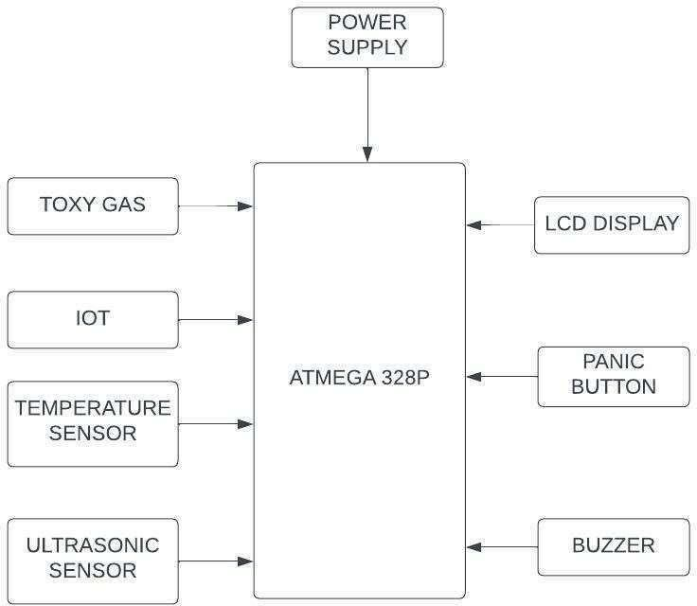

Fig 4.1 Monitoring system for sewage workers

## FLOW DIAGRAM

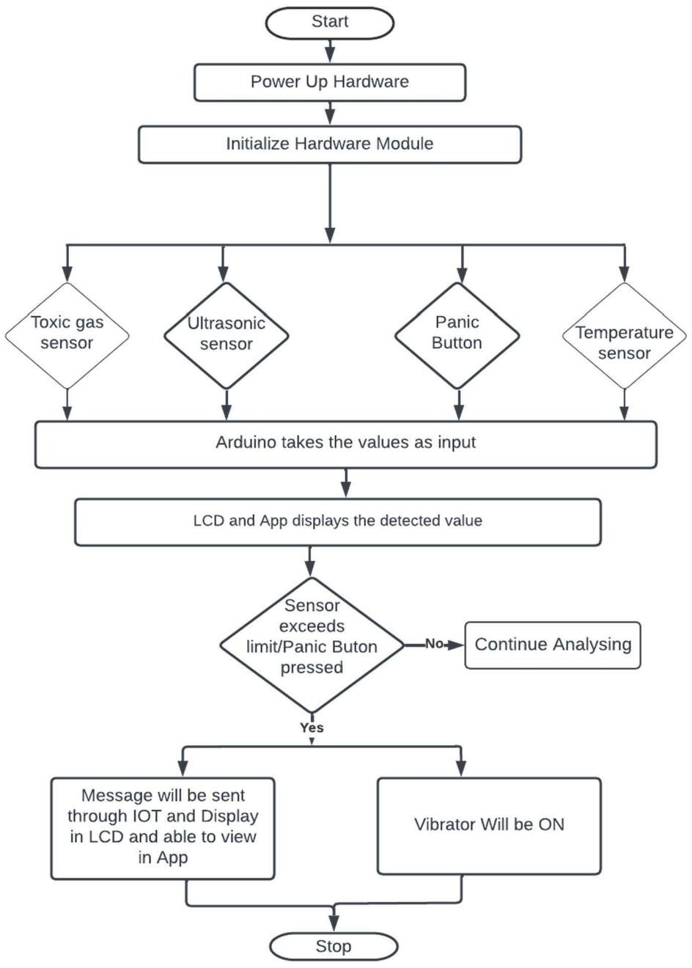

Fig 4.2 Work flow of the monitoring system

## CHAPTER 5

## HARDWARE REQUIREMENTS

**POWER SUPPLY CIRCUIT**

Power supply is a reference to a source of electrical power. A device or system that supplies electrical or other types of energy to an output load or group of loads is called a power supply unit or PSU. The term is most commonly applied to electrical energy supplies, less often to mechanical ones, and rarely to others.

Power supplies for electronic devices can be broadly divided into linear and switching power supplies. The linear supply is a relatively simple design that becomes increasingly bulky and heavy for high current devices; voltage regulation in a linear supply can result in low efficiency. A switched- mode supply of the same rating as a linear supply will be smaller, is usually more efficient, but will be more complex.

## Transformer

Transformers convert AC electricity from one voltage to another with little loss of power. Transformers work only with AC and this is one of the reasons why mains electricity is AC. Step-up transformers increase voltage, step-down transformers reduce voltage. Most power supplies use a step- down transformer to reduce the dangerously high mains voltage (230V in UK) to a safer low voltage.

The input coil is called the primary and the output coil is called the secondary. There is no electrical connection between the two coils; instead they

are linked by an alternating magnetic field created in the soft-iron core of the transformer. The two lines in the middle of the circuit symbol represent the core. Transformers waste very little power so the power out is(almost) equal to the power in. Note that as voltage is stepped down current is stepped up. The ratio of the number of turns on each coil, called the turn’s ratio, determines the ratio of the voltages. A step-down transformer has a large number of turns on its primary (input) coil which is connected to the high voltage mains supply, and a small number of turns on its secondary (output) coil to give a low output voltage.

## Bridge rectifier

A bridge rectifier can be made using four individual diodes, but it is also available in special packages containing the four diodes required. It is called a full-wave rectifier because it uses the entire AC wave (both positive and negative sections). 1.4V is used up in the bridge rectifier because each diode uses 0.7V when conducting and there are always two diodes conducting, as shown in the diagram below. Bridge rectifiers are rated by the maximum current they can pass and the maximum reverse voltage theycan withstand (this must be at least three times the supply RMS voltage so the rectifier can withstand the peak voltages). Most power supplies use a step-down transformer to reduce the dangerously high mains voltage (230Vin UK) to a safer low voltage.

## Regulator.

Voltage regulator ICs are available with fixed (typically 5, 12 and 15V) or variable output voltages. They are also rated by the maximum current they can pass. Negative voltage regulators are available, mainly for use in dual supplies. Most regulators include some automatic protection from excessive current and overheating ('thermal protection')

The LM78XX series of three terminal regulators is available with several fixed output voltages making them useful in a wide range of applications. One of these is local on card regulation, eliminating the distribution problems associated with single point regulation. The voltages available allow these regulators to be used in logic systems, instrumentation, Hi-Fi, and other solid state electronic equipment. Although designed primarily as fixed voltage regulators these devices can be used with external components to obtain adjustable voltages and current.

## ARDUINO UNO

The Arduino UNO is an open-source microcontroller board based on the Microchip ATmega328P microcontroller and developed by Arduino.cc. The board is equipped with sets of digital and analog input/output (I/O) pinsthat may be interfaced to various expansion boards (shields) and other circuits. The board has 14 Digital pins, 6 Analog pins, and programmable with the Arduino IDE (Integrated Development Environment) via a type BUSB cable.

AC voltage makes them oscillate at the same frequency and produce ultrasonic sound. Capacitive transducers use electrostatic fields between a conductive diaphragm and a backing plate. The beam pattern of a transducer can be determined by the active transducer area and shape, the ultrasound wavelength, and the sound velocity of the propagation medium.

**LIQUID CRYSTAL DISPLAY**

A liquid crystal display (LCD) is a flat panel display, electronic visual display, or video display that uses the light modulating properties of liquid crystals.

Liquid crystals do not emit light directly. LCDs are available to display arbitrary images (as in a general-purpose computer display) or fixed images which can be displayed or hidden, such as preset words, digits, and 7-segment displays as in a digital clock. They use the same basic technology, except that arbitrary images are made up of a large number of small pixels, while other displays have larger elements.

## BUZZER

A buzzer or beeper is a signalling device, usually electronic, typically used in automobiles, household appliances such as a microwave oven, or game shows. It most commonly consists of a number of switches or sensors connected to a control unit that determines if and which button was pushed or a preset time has lapsed, and usually illuminates a light on the appropriate button or control panel, and sounds a warning in the form of a continuous orintermittent buzzing or beeping sound.

**TOXIC GAS SENSOR (MQ6)**

A gas detector is a device that detects the presence of gases in an area, often as part of a safety system. This type of equipment is used to detect a gas leak and interface with a control system so a process can be automatically shut down. A gas detector can sound an alarm to operators in the area where the leak is occurring, giving them the opportunity to leave. This type of device is important because there are many gases that can be harmful to organic life, such as humans or animals. Gas detectors can be used to detect combustible, flammable and toxic gases, and oxygen depletion. This type of device is used widely in industry and can be found in locations, such as on oil rigs, to monitor manufacture processes and emerging technologies such as photovoltaic. They may be used in firefighting. Gas leak detection is the process of identifying potentially hazardous gas leaks by sensors. These sensors usually employ an audible alarm to alert people when a dangerous gas has been detected. Common sensors include infrared point sensors, ultrasonic sensors, electrochemical gas sensors, and semiconductor sensors. More recently, infrared imaging sensors have come into use. All of these sensors are used for a wide range of applications and can be found in industrial plants, refineries and wastewater treatment facilities.

## TEMPERATURE SENSOR (DHT11)

The basic principle of working of the temperature sensors is the voltage across the diode terminals. If the voltage increases, the temperature also rises, followed by a voltage drop between the transistor terminals of base and emitter in a diode.

Besides this, En cardio-Rite has a vibrating wire temperature sensor that works on the principle of stress change due to temperature change. The vibrating wire temperature meter is designed on the principle that dissimilar metals have a different linear coefficient of expansion with temperature variation.

It primarily consists of a magnetic, high tensile strength stretched wire, the two ends of which are fixed to any dissimilar metal in a manner that any change in temperature directly affects the tension in the wire and, thus, its natural frequency of vibration.

It uses a capacitive humidity sensor and a thermistor to measure the surrounding air, and outputs a digital signal on the data pin (no analog input pins needed). It is very simple to use, and libraries and sample codes are available for Arduino and Raspberry Pi. This module makes is easy to connect the DHT11 sensor to an Arduino or microcontroller as includes the pull up resistor required to use the sensor. Only three connections are required to be made to use the sensor – Vcc , Gnd and Output.it has high reliability and excellent long-term stability, thanks to the exclusive digital signal acquisition technique and temperature & humidity sensing technology

## ULTRASONIC SENSOR

Our ultrasonic distance, level, and proximity sensors are commonly used with microcontroller platforms like Raspberry Pi, ARM, PIC, Arduino, Beagle Board, and more. Ultrasonic sensors transmit sound waves toward a target and will determine its distance by measuring the time it took for the reflected waves to return to the receiver. The HC-SR04 ultrasonic sensor uses SONAR to determine the distance of an object just like the bats do. It offers excellent non-contact range detection with high accuracy and stable readings in an easy-to-use package from 2 cm to 400 cm or 1” to 13 feet.

Ultrasonic sensors work by sending out a sound wave at a frequency above the range of human hearing. The transducer of the sensor acts as a microphone to receive and send the ultrasonic sound. Our like many others, use a single transducer to send a pulse and to receive the echo. The sensor determines the distance to a target by measuring time lapses between the sending and receiving of the ultrasonic pulse.

## PANIC BUTTON

A panic alarm is an electronic device designed to assist in alerting somebody in emergency situations where a threat to persons or property exists. A panic alarm is frequently but not always controlled by a concealed panic alarm button. These buttons can be connected to a monitoring center or locally via a silent alarm or an audible bell/siren. The alarm can used to request emergency local security, police or emergency services. Some systems can also activate closed-circuit television to record or assess the event

## CHAPTER 6

## HEALTH-IOT PLATFORM BASED

In-home healthcare services based on the Internet-of Things (IoT) have great business potential; however, a comprehensive platform is still missing. In this paper, an intelligent home-based platform, the iHome Health-IoT, is proposed and implemented. In particular, the platform involves 1) an open-platform-based intelligent medicine box

(iMedBox) with enhanced connectivity and interchangeability for the integration of devices and services, 2) intelligent pharmaceutical packaging (iMedPack) with communication capability enabled by passive radio-frequency identification (RFID) and actuation capability enabled by functional materials, and 3) flexible and wearable bio-medical sensor

device (Bio-Patch) enabled by the state-of-the-art inkjet printing

technology and system-on-chip.

## CHAPTER 8

## CONCLUSION

This device is being designed keeping in mind, the measurement of

necessary parameters, which needs to be monitored for unhindered safety of the sewage workers. The device finds major application in household sewage systems, municipal manholes and sewage, sewer, deep well, gutters and drains etc. However, the places where toxic gases or fumes are present should never be handled by human workers directly. The sewage system is an efficient and economical device, cost around 10,000INR compared to available safety equipment. In country like India, where sewage is mostly cleaned by humans, which makes this device useful around India.

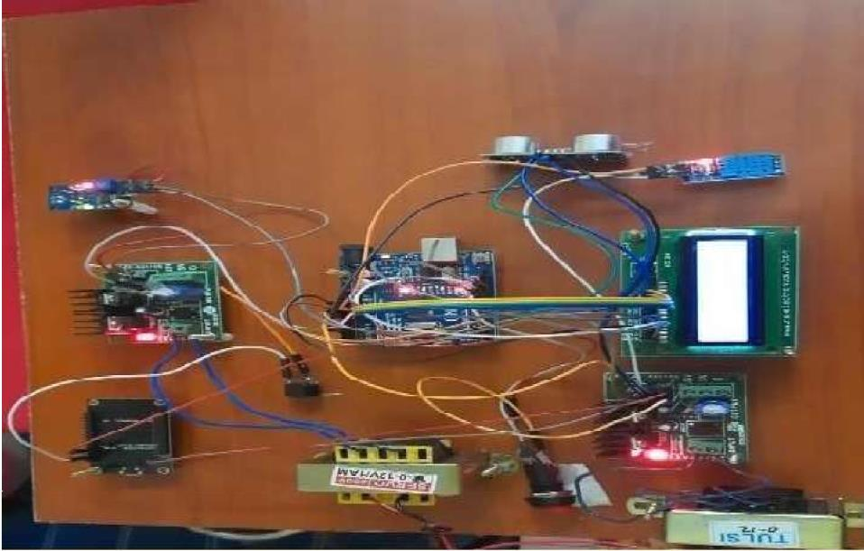

Fig 8.1 IoT Setup

# REFERENCES

1. I. Akyildiz, W. Su, Y. Sankarasubramanian, E. Cayirci(2002), “ASurvey on Sensor Networks”, IEEE Communications Magazines.
2. Ebrahim Y., and Abdel-Shakour A. (2003). “Respiratory Health Problems of Sewage Workers.” Environmental and Occupational Medicine Department, and Air Pollution Research Department National Research Center.
3. Fioccola, G. B., Sommese, R., Tufano, I., Canonico, R., and Ventre,

G. (2016).“Polluino: An efficient cloud based management of IoT devices for air quality monitoring.” (2016) IEEE 2nd International Forum on Research and Technologies for Society and Industry Leveraging a better tomorrow (RTSI), 1–6.

1. R. Girisrinivaas and V. Parthipan, “Drainage overflow monitoring system using IoT (DOMS),” (2017) IEEE International Conference on Power, Control, Signals and Instrumentation Engineering (ICPCSI), Chennai, pp. 2133-2137.
2. Hamid Raeisi Vanani1, Mohammad Shayannejad1, Ali Reza Soltani Toudeshki1, Mohammad Ali Arab1, Saeid Eslamian1, Vijay P. Singh2, Kaveh Ostad-Ali-Askari(2018). “Feasibility Study for Improving the Quality of Refined Sewage Due to the Advancement of Soil.” Water Engineering Department, Isfahan University of Technology, Isfahan, Iran. Department of Biological and Agricultural Engineering Zachry Department of Civil Engineering, Texas A and M University, 321 Scoates Hall, 2117 TAMU, College Station, Texas, U.S.A.
3. Hamzeh Al Zabadi, Luc Ferrari, Irene Sari-Minodier, (2011)MarieAude

Kerautret, Aziz Tiberguent, Christophe Paris, Denis

ZmirouNavier, “Integrated Exposure Assessment of Sewage Workersto Genotoxicants: an Urinary Biomarker Approach and

Oxidative

Stress Evaluation”, Environmental Health Journal.

1. Haswani, Navin Deore, Pramod (2018). Web-based real time underground drainage or sewage monitoring system using Wireless Sensor Networks.
2. S.D.T. Kelly, N.K. Suryadevara, S.C. Mukhopadhyay(2013), “Towards the Implementation of IoT for Environmental Condition Monitoring in Homes”, Sensors Journal IEEE, vol. 13, no. 10, pp. 3846-3853.
3. Keshamoni, K. and Hemanth, S. (2017). “Smart gas level monitoring, bookingamp;amp;gas leakage detector over iot.”IEEE

7thInternational Advance Computing Conference (IACC), 330–332 (Jan).

1. Lazarescu, M.T.(2013), “Design of a WSN Platform for Long-Term Environmental Monitoring for IoT Applications,” Emerging andSelected Topics in Circuits And Systems, IEEE Journal on, vol.3,

no.1, pp.45, 54.

1. Liu, Z., Wang, Z., Chen, R., and Wu, X (2008). “Intelligent residential security alarm and remote control system based on single chip computer.”3rd IEEE Conference on Industrial Electronics and Applications, 159–161 (June).
2. Mayank Mrinal, Anubha Mandal, Anunay Gour, Lovleen Gupta, “Evaluation of Green House Gases Emissions from Sewage Treatment Plants”,(2016) International Research Journal ofEngineering and Technology (IRJET).
3. Prof Muragesh SK1, Santhosha Rao2(2015), “Automated Internet of

Things For Underground Drainage and Manhole Monitoring Systems For Metropolitan Cities”. International Journal of InnovativeScience, Engineering Technology, Vol. 2 Issue 4.

1. Nitin Asthana, Ridhima Bahl.(2019) “IoT Device for Sewage Gas Monitoring and Alert System”.
2. Prof S. A. Shaikh1, Suvarna A. Sonawane(2017), “Monitoring

Smart City Application Using Raspberry PI based on IoT” International Journal of Innovative Science, Engineering Technology, Vol 5 Issue VIL.

1. B. Sumathy, G. Gowthaman, K. Hari Haran, G. Keerthee Rajan, A. Sweeto Jeison, (2018). Sewage Level Maintenance Using Iot. International Journal of Mechanical Engineering and Technology (IJMET).Volume:9,Issue:2,Pages:389- 397.
2. Yash Narale, Apurva Jogal, Himani Choudhary, S. P. Bhosale.(2018)Underground Drainage Monitoring System Using IoT
3. ,I nternational Journal of Advance Research, Ideas and Innovations in Technology.

